**What is GitHub Apps?**

GitHub Apps are first-class actors within GitHub. A GitHub App acts on its own behalf, taking actions via the API directly using its own identity, which means you don't need to maintain a bot or service account as a separate user(source: Official Documentation).

**How can GitHub apps be used?**

GitHub apps can be installed either on the organization or on an account. Once the app is installed either you can grant the app access to a particular repository within the organization or grant access to all the repository within the organization.

**What can GitHub apps be used for?**

GitHub apps come with built-in web-hooks and narrow access to the various permission. For example, if you are the owner of a repository then you can choose which events the github app can listen to. You can either deny any permission or just give Read Only permission or grant Read & Write permission to a particular type of github events such as pull request, commit statuses etc.

**How can one install the GitHub App?**

In order to install the GitHub app one need to host it somewhere. For step-by-step instructions that cover servers and hosting, see "[Building Your First GitHub App](https://developer.github.com/apps/building-your-first-github-app)."

As per my understanding, we can either develop a single script or an entire standalone application which can then be hosted as a GitHub app. However, in our case, we need github just to configure web-hook and set different permissions from one place rather configuring it on multiple repositories

As per our use case, the following are the features we would use in our github app:

* Configure github controller web-hook on an account/organization
* Edit the permissions and subscribe to the events for which we need data in Jarvis
* Select the repository/repositories on which the app should be installed

**Steps to Register Github app**

1. Login to your github account using windows credentials
2. Select **Settings** option from the top-right drop down menu as shown below  
     
   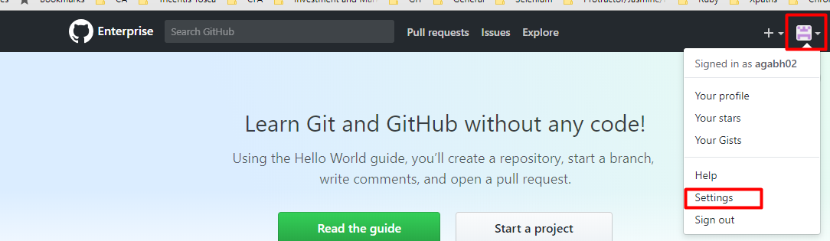
3. Select **Developer Settings** from left pane
4. Select **GitHub Apps** from the left pane
5. Click on **New GitHub App** to start configuring the github app
6. On **Register new GitHub App** page fill in the details as follows
   1. 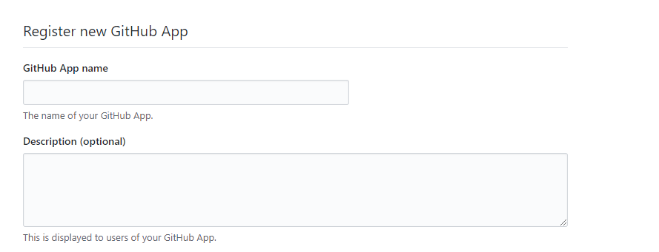  
        
      Enter your **GitHub App** name in the respective field. This is the name which will be seen by others as your GitHub App.

Provide **Description** in the text area provided. Though it is optional to provide the description but still it is recommended that you provide one as it helps the users to know what the app is about.

* 1. 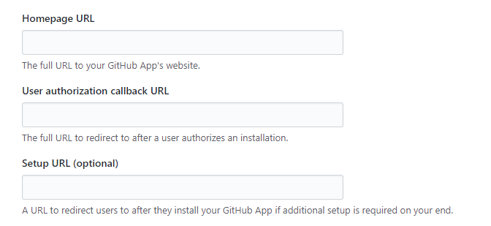  
       
     Next filed is **Homepage URL** where you’ll provide the full URL to your GitHub app. This field is a **required** one and thus you cannot leave this blank. If you don’t have any homepage created you can just give the hostname (full URL; For Example, https://www.example.ca.com , assuming your GitHub app is hosted on a machine whose name is **example**) with complete URL. In my opinion it is better to create at least **About** page which just describe about your GitHub app and list the features it offers out of the box.  
       
     **User authorization callback URL:** This field expect the URL of the webpage which user should see once they authenticate themselves to access the app. For example, say you’re application need a user to authorize themselves using the valid credentials; Once the user is authenticated you want to land them to main page of your GitHub App. Though it’s not specified if this field is required, I have not used this field and my application still worked.  
       
     **Setup URL (optional):** In case your application need some additional setup after the user is authenticated but before using the actual application, then you can use this field to redirect the user to appropriate page where further setup instructions are available.
  2. 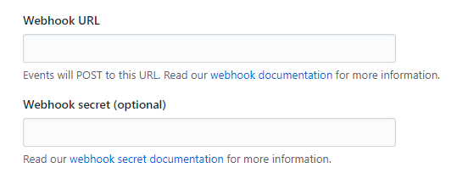  
       
     **Webhook URL:** This is the URL to which all the payloads, generated from various GitHub events, will be posted. This is a **required** field and this is where I have configured the GitHub Controller web-hook developed for Data Factory.  
     **NOTE:** Please note that this web-hook will be applied to all/selected repositories under the organization on which this GitHub app is installed.  
       
     **Webhook secret (optional):** I am not sure what this field is for but as seen this is an **optional** filed. If I get to know more about the usage of this field, I’ll edit this document.
  3. Next section you’ll see on this page is **Permissions** where you can grant/revoke the access to set of different event types. For each permission you have 3 options: **No access**, **Read Only**, **Read & Write**.  
     Based on the Access set for a permission you’ll see events related to that type under **Subscribe to events** section (section next to this one).
  4. **Subscribe to events** section  
     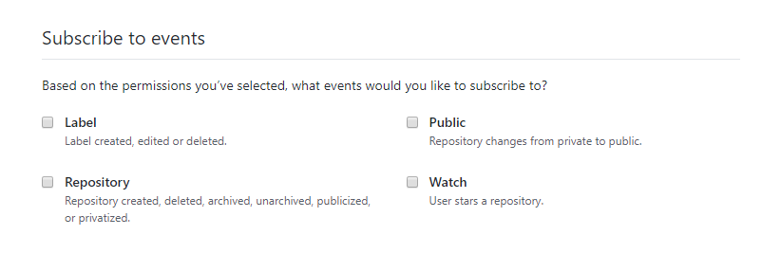  
     As you see in the image, based on the permissions you’ve selected in last section, this section will display various events which you can subscribe to.  
      **NOTE:** All the subscription you select on this page will be applicable to all/specific repositories under the organization on which this GitHub app is installed.   
     **TODO:** I need to find out how one can revoke specific event subscription only for a specific repository in the organization.  
     **Answer**: We cannot have special settings only for specific repository and having another setting for rest of the repository in the same organization.
  5. 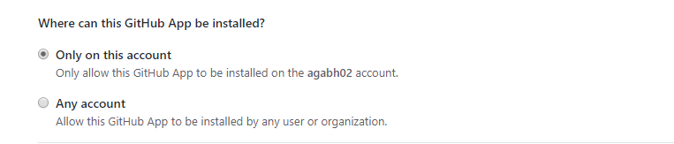  
       
     You can choose to install this app either on your account or any other account within your company.  
       
     **TODO:** I need to verify **Any account** option functionality.

1. Once you made the settings as described above, click **Create GitHub App.** This will create the app and now you can install the same on other user account or any other organization to which you have access.

**How to install Github app on a given account/organization?**

After Registering a new Github app you’ll see the app listed under **Github Apps** section of **Settings/Developer settings** page as shown below.

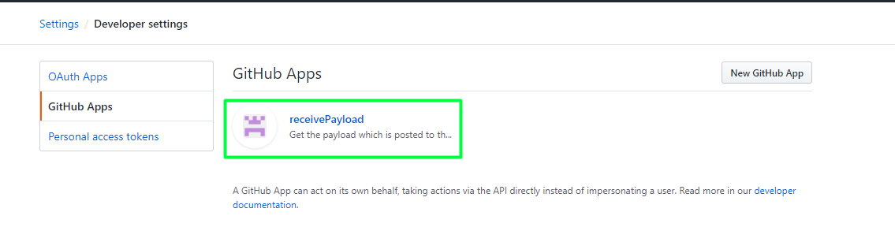

1. Click on the **Github App**
2. On **GitHub App** page Select **Install App** from left hand pane as shown below  
     
   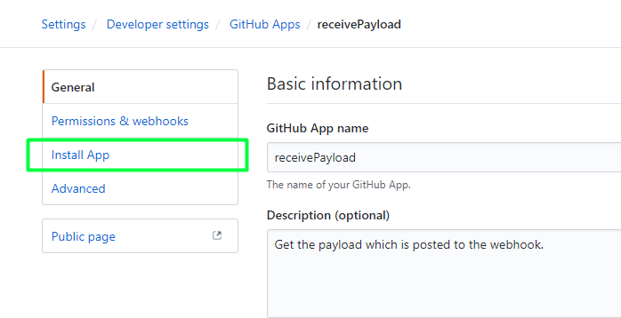
3. On **Install App** page you’ll see the list of account(s)/organization(s) you have access to  
     
   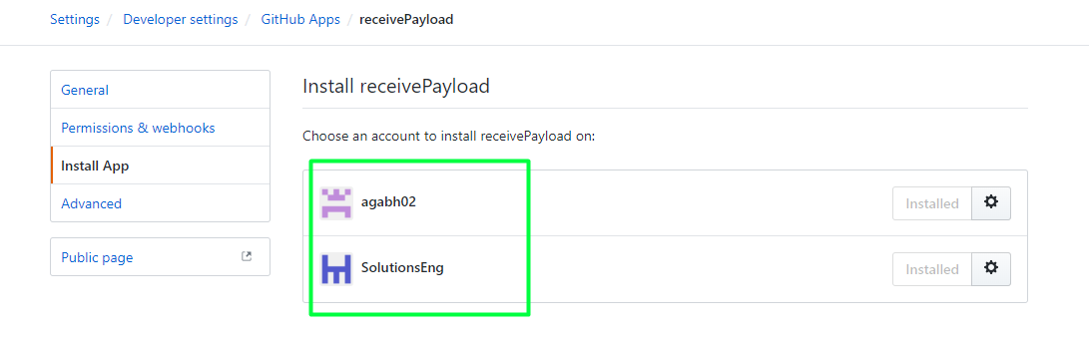
4. Beside your account name/organization name (which you have access to), you’ll see a button named **Install;** Click the same to install.

During installation it’ll ask you to select either all or specific repository to configure the app. Please follow the instructions on installation page to complete the installation.

**Effect of changing permissions of GitHub app:** Once you install the GitHub app on account(s)/Organization(s), settings available in GitHub App (web-hook, events subscription etc.) will be applied to those account(s)/organization(s). Now, whenever the owner of the app or account on which app is installed, makes changes to any settings such as Web-hook update, adding/removing of github events’ subscriptions etc., the owner of each account/organization will be notified about the change via email and need their approval to apply the changes to their account/organization.

For example, say while installing the GitHub app it has no subscription to listen to any events generated from **Issues** and when it is installed by some user account(s)/organization(s) the same settings (no subscription to Issues) will be applied to all the repositories under the installed user account(s)/organization(s). Now if you make a change to the app to subscribe to **Issues** the change will be notified to owner of all account(s)/organization(s) which has the app installed.

Request for new permission will look alike as shown in the image below:

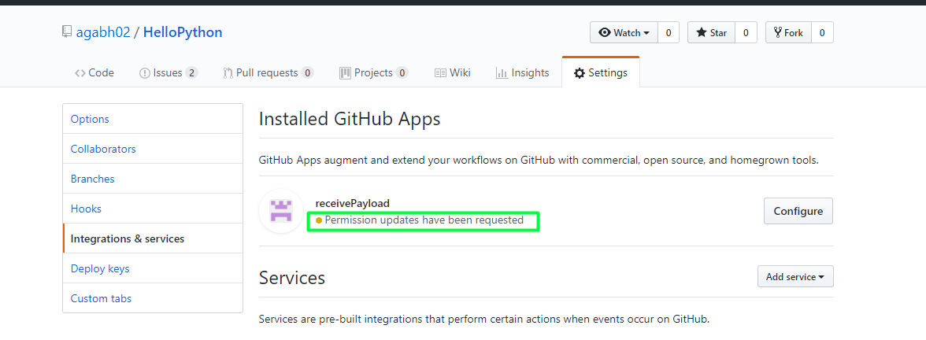

To visit this page:

* Go to your repository
* Switch to **Settings** tab
* Select **Integrations & services** from left pane
* Click on **Configure** button beside the GitHub app as shown in the image above

Once you click on **Configure** button you’ll see the page as shown below:

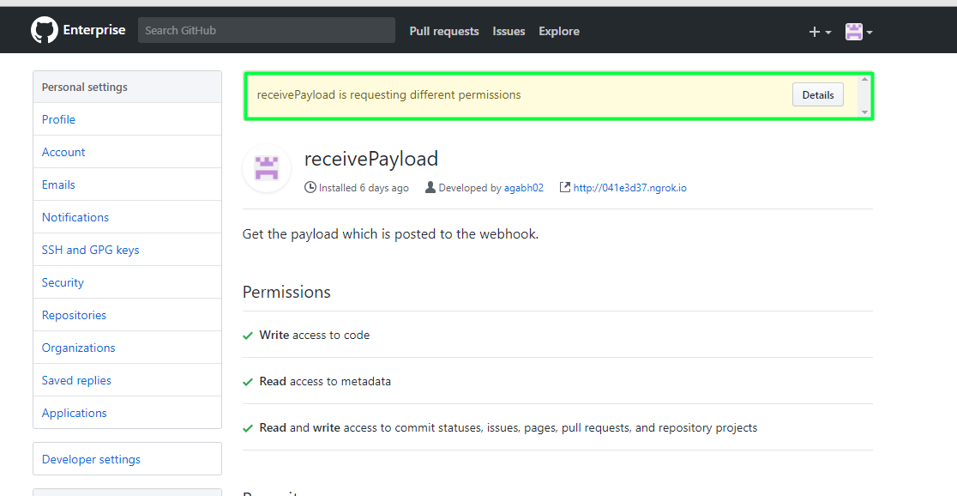

* Click on **Details** button to see the permissions requested

Once you click **Details** button you’ll see the page as shown below:

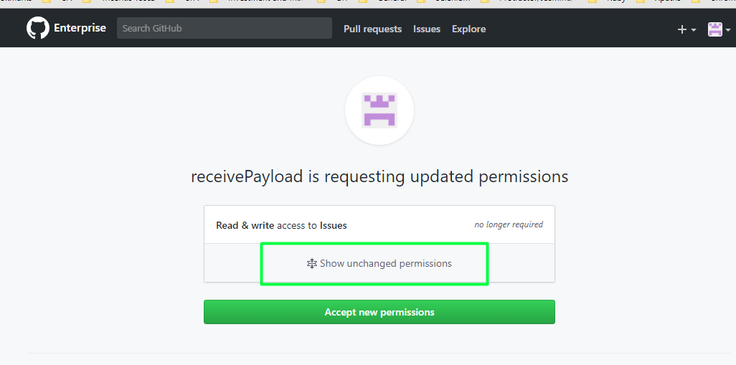

* Click on **Show unchanged permissions** to see the other permissions which are still intact
* Notice the text above the highlighted area in the above image; this is where you’ll know about the changes in permission requested.

Now, it is up to repository owner if they want to accept the changes in permission or not. If you don’t accept the permission changes your repository will be exempted from the new changes.

**How to change permissions in GitHub app?**

1. Go to **Settings** page from top-right drop-down menu  
   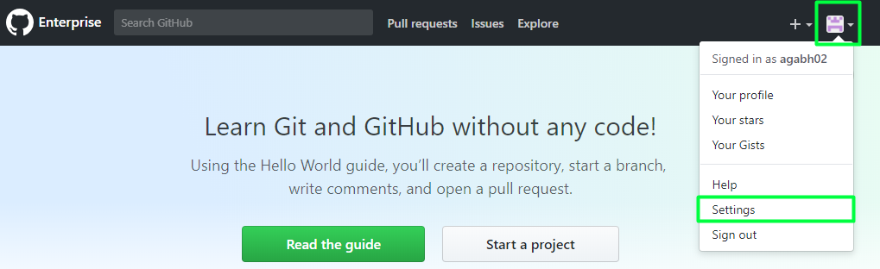
2. Select **Developer Settings** from left pane
3. Select **GitHub Apps** from the left pane
4. Select **GitHub** app for which you are willing to change permissions from the right-side pane  
   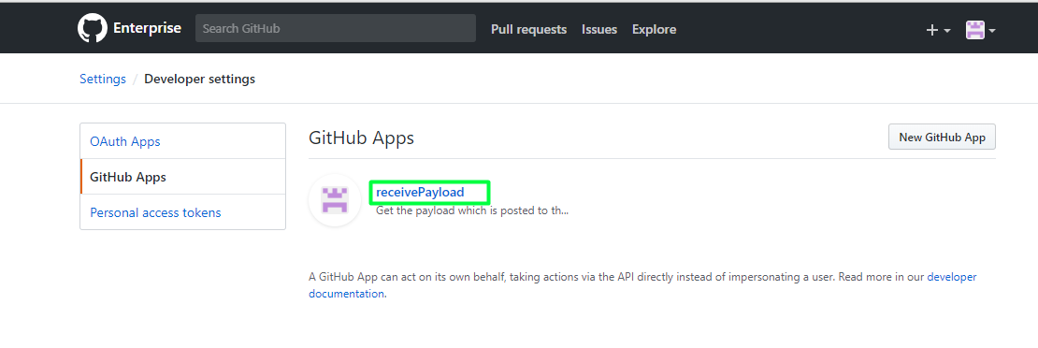
5. Select **Permissions & webhooks** tab from left side pane  
   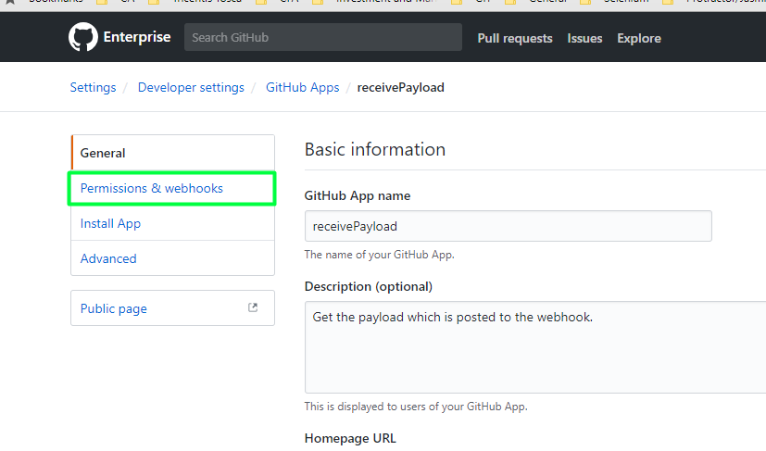

On **Permissions & webhooks** page you can make changes to various permissions and subscribe/unsubscribe to various github events. Once you make the changes click on **Save changes** button at the bottom of webpage (this will trigger an email to account(s)/organization(s)/repositories(s) owner which has this app installed)

**Viewing list of Accounts/Organizations which is consuming the app**

1. Go to **Settings** page from top-right drop-down menu  
   
2. Select **Developer Settings** from left pane
3. Select **GitHub Apps** from the left pane

Select **GitHub** app  


1. Select **Public page** option from left hand pane
2. Click **Configure** button from the webpage as shown below  
   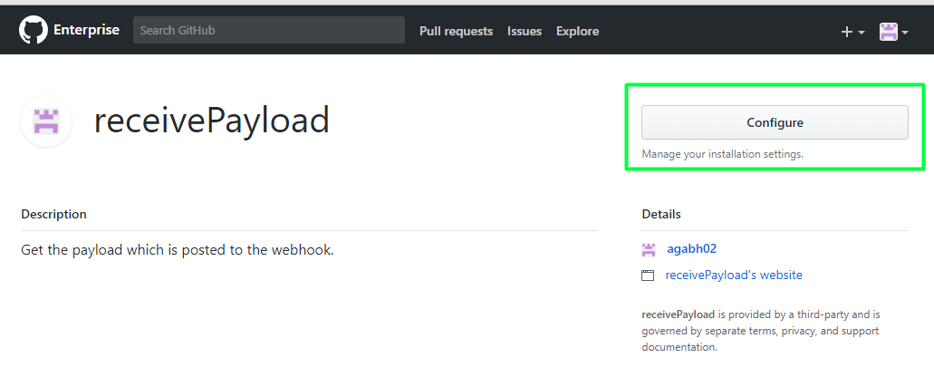
3. Next page will show you list of account(s) and Organization(s) you have access to (here, by access I mean you should be the owner of account(s)/organization(s)). From this page you can see which organization(s) are already using your github app. If any account(s)/organization(s) is not using the app it’ll show **Install** button beside the account(s)/organization(s). The overview of page is shown below  
   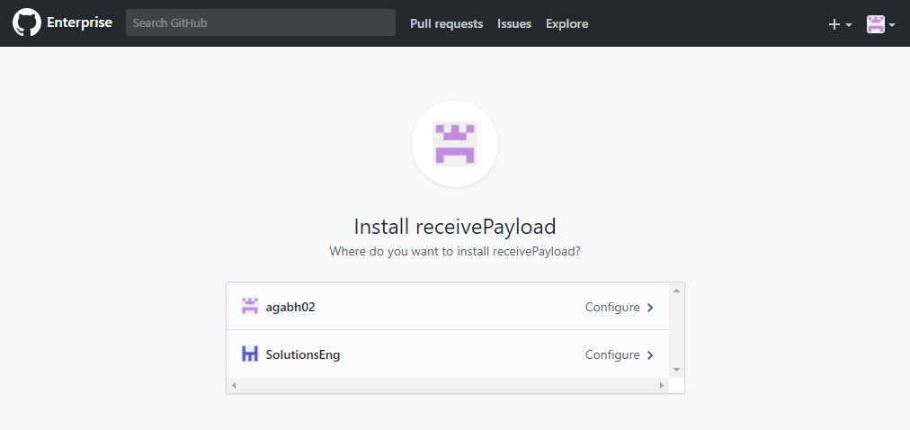

**How to uninstall the GitHub app?**

If one wish to opt-out from the GitHub app or in simple terms if they wish to uninstall the app then they can do it by following the instructions given below:

1. Go to the repository for which you want to remove GitHub app.
2. Select **Settings** tab
3. Select **Integrations & services** from the left side pane
4. Click on **Configure** button appearing next to the GitHub app that you want to uninstall
5. Scroll to the bottom of the page and Click on **Uninstall** button from **Uninstall <GitHub App name>** section.
6. Click on **Yes, uninstall <GitHub App name>** button in the **Uninstall <GitHub App Name>** confirmation box.

**NOTE:** You can uninstall GitHub app from a repo only if you have admin access to the organization in which this repo exists. Also, given you have admin access to organization and you want to uninstall a GitHub app only for a specific repo then **DO NOT UNINSTALL** it as it’ll completely remove the app from organization. You need to select **Only select repositories** (if not already selected) followed by adding all other repositories (if **All repositories** was selected earlier) except the one which you didn’t want to have this GitHub App.

**Caveat with GitHub Apps**

1. You cannot install the app which is not available in the organization in which your repo exists.
2. Currently, organization admin can decide either all repo or specific repos should have the GitHub app configured.
3. Repository owner cannot uninstall the installed github app on their repo if they don’t have admin access to organization in which repo exists.
4. If the github app is configured on all repositories then it is not possible to uninstall the app only for specific repository.  
   Refer <https://platform.github.community/t/why-cant-repository-admins-install-integrations-in-their-repository/882/10> & <https://platform.github.community/t/adding-an-integration-when-not-an-admin/1509> for more details on above 4 points mentioned.
5. As a repository owner if you want to identify what events the github app configured for your repo then it is not possible. I have raised [a ticket](https://platform.github.community/t/as-a-repository-owner-how-should-i-know-what-events-subscribed-by-installed-github-app/6620) with GitHub team and they would probably work on developing such feature.

**Important points to note**

1. Say, you have github app installed at account level and it has some default settings, but you want to have different settings for your repo/organization; then you have two options
   1. Configuring same web-hook end point within the specific repository will overwrite the settings that comes with the github app having the same web-hook end point
   2. One can create another Github app with same web-hook end point and configure the permissions, events needed. Now you can install this app either on all/specific repo(s). In this case, global settings, which comes with previously installed github app having the same web-hook end point, will not be overwrite and hence both the github app will continue to function.
2. While we have github app installed, it doesn’t mean that you cannot use the **Hooks** feature to configure any other end point. In case you got any other web-hook end point and you want to register to some events for your repository then you are free to do so. Newly added hooks will not affect the github app unless it has the same web-hook end point, in which case web-hook configured at repo level take over the priority.

Please contact **Bhupender Agarwal(**[agabh02@ca.com](mailto:agabh02@ca.com)**)** if you see a scope to modify/add new content to this document.